Food Classification

First A. Author, *Prashuk Jain*

***Abstract*-Classification model is a trend of deep learning. Designing a model which can predict the food image is not an easy task. There are a lot of ways or say experiments which are done to make a classification model. The main purpose of this report is to tell how we are going to implement these models and main purpose behind implementing all these models. We are also going to take a look at how we can use TensorFlow on how to implement all these models and some other awesome libraries to understand how they work and how we can use them to make a precise model. We are going to take a look at ways to make our model better and also take a look the at the ways which bring a huge change in our model. We are going to create different models and understanding the difference between them. The main motive behind building these models is to provide a better understand of TensorFlow and implementing all these topics from a particular perspective.**

***keywords****: Neural Network, Image recognition, Convolutional Neural Network, Food-101 Dataset, Deep Learning, Supervised learning, pre-processing*

INTRODUCTION

Image prediction models are an important aspect of deep learning. There are a lot of models which are used for image prediction. We are trying to create our own model to predict the image. For the image prediction we are going to use convolutional network. With the help of deep learning, image classification model can convert the human eye power to machine with the help of convolutional network.

Convolutional network is a deep learning model that help to understand the images. This model can help to determine low to high feature of a particular image[1]. We are going to make some experiment on convolutional neural network. The main purpose of our project is not making an outstanding model. But to make different models so that we can check how the parameters impact the model. We are going to use some data processing techniques so that we can get some amazing results. In the evaluation part we are trying to analyse the predictions with the help of graphs and values.

This project explores food image classification with convolutional neural networks for better image labelling and clustering by dish, which

in turn may improve the recommendation and search flows for a better digital food user experience overall. Specifically, the goal of the project is to, given an image of a dish as the input to the model, output the correct label categorization of the food image. Then we try to plot the image so that we can get a better look at result than we try to analyse the result that the place we are going wrong.

Now there are some important points which we need to know for implementing data pre-processing. The main point behind implementing data pre-processing is to make system easily digest the data which we are putting into it [2]. For that We are first going to reduce the size of image. Now reducing the size of image means standardising the values of pixel. The next main point of data pre-processing is analysing some values. Now analysing values is simple but to analyse images we need a particular way. For that we are going to plot pixels value on graphs and get the image.

Now after all the data pre-processing, we are going to build some basic model or in other word we can say baseline model. A baseline model plays a vital role in moving forward for making model[3]. With the help of baseline model, we can understand how much we need to improve the ways to improve and the points where we need to improve and the result of which we can get a direction in which we need to move. Now the next important step is to change the configuration of our model so that we an get some better results like increasing epochs, increasing or decreasing learning time, using some other optimisation variable.

Now the best change in any model is introducing different layer which is perfect for that particular type of problem. As we are creating an image classification model, we are most probably going to use a convolutional layer which help to detect different details of pixels. We are also going to do some experiment with convolutional layer. We are also trying to show the different problems with every model and how we are going to solve them.

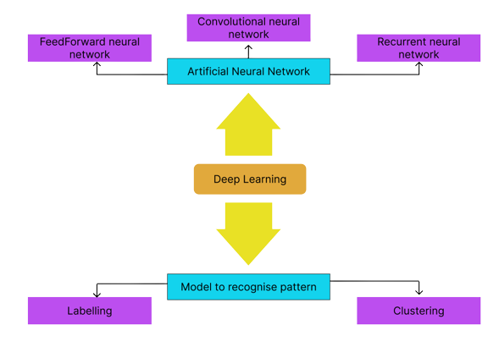

Figure 1 – Different part of deep learning

RELATED WORK

The dataset used in this project is a 101-food dataset. Now directly creating a model which can distinguish between 101 food is not simple. So, we are going to use all the food labels. Now the next part of problem is are we really able to create a model which can classify 101 types of foods. Now to answer this we need to do more and more experiments. Next, we are going to make changes our inputs so that we are able to get some great result in our model. Now for this we are going to do the data pre-processing which can be done in many different ways and can be done on different type of data. But we mostly going to use the most effective ways of data pre-processing because doing a lot of data pre-processing can lead to overfitting of the model. Now as we are using image as an input, we need to also plot pixels point on the charts so that we can get a better visual look at the images.

Now the next important part is creating different models for our inputs. There are a lot of models which can be created to get results but making a lot of models is not just a good idea. Its better that we create most important and some baseline model and try to configure them according to the results. For a simple example we first create a simple model and see how much result we can get. Now most of the people know that for image classification convolutional neural network perform way better and show amazing result. So yes, we are going to create one convolutional neural network but not in the beginning because our motive is not creating a great model which can provide the best prediction but to create different models and try to compare the results and found some reasons why convolutional model perform so perfectly and what configuration we need to use to make our model more robust and provide slight improvements.

Now the next important thing is visualising and analysing the results. Now to improve our model it is important that we know what are problems with our earlier model and how can we fix that problem. For that we are going to create confusion matrix looking some of the scores like f1-score, recall, precision etc. We are also going to look at the points at which our model is mostly problematic and then understanding why it showing problem at those points. The main purpose of analysing the results is to get a better understanding of model and we also going to get a summary of our models which will provide how our model is connected with other layers. With the help of all this we are going to provide a great project which will help to get amazing answers to some of the hardest questions of Artificial intelligent.

METHODOLOGY

The process of ‘**Food Classification Model**’ work on the basis of data mining technique[4]. The most important techniques of data mining which is used in this project is Convolutional neural network Algorithm and comparison’s have been made with the results of convolutional neural network from other algorithms like linear model. The main reason for choosing Convolutional neural network is our technology is high accurate predictions which we are going to get after putting food images as input in the model[5]. From the information above we can conclude that the convolutional neural network is the best choice if we have images as input because convolutional neural network model are designed particularly for image classification. Data Mining in AI use some special tools and applied to the processed data which help to classify the food and than get information about that food so that we can get an overview for a unhealthy person that is to proper for the person. With the help of many different images of food in different ways we are going to train model perfectly so that we get the desired output with better accuracy using the convolutional neural network[6]. Health of a human has become a global issue. Everyone is eating just fast food without knowing the stats of that food. To overcome this problem we are going to create a model which will help to classify the food and than provide the information about the food[7].

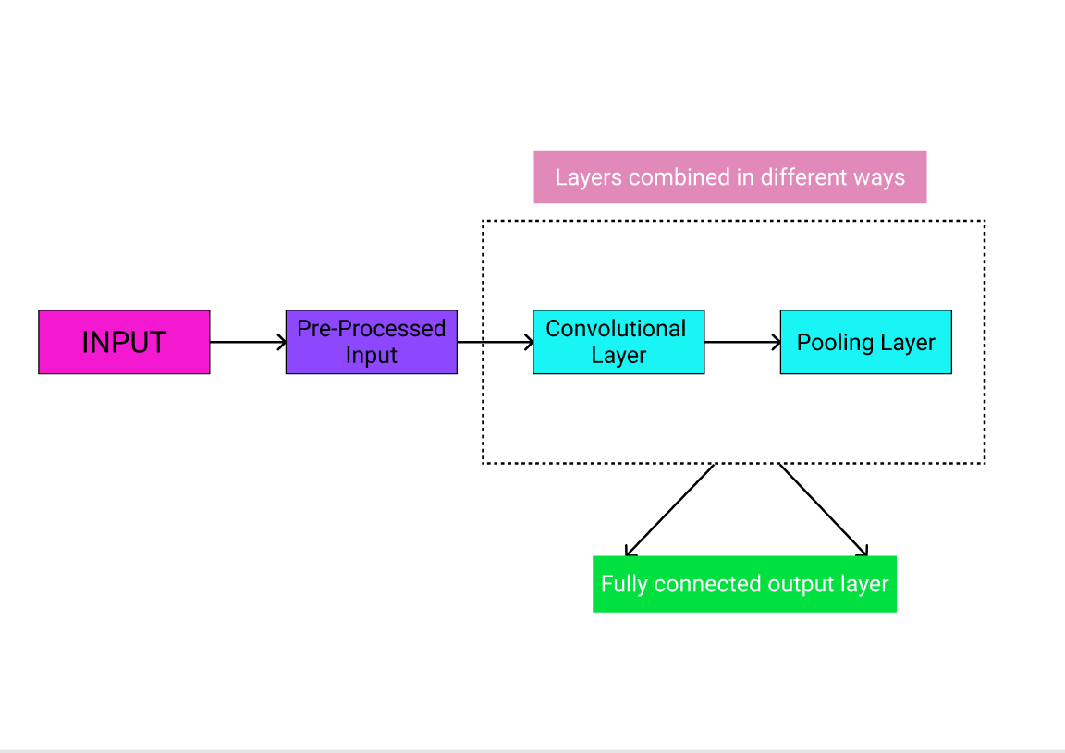

Figure 2 – Showing how a convolutional neural network works

FOOD-DATASET

Dataset plays a vital role in any deep learning model more than anything. The main reason for this is that we need a large dataset of raw data which is need to put inside the model and teach it. Neural network of a model try to learn from the dataset create a pattern, upgrade the pattern and then improve with each iteration. The more the quantity of raw data is feed to the model the more pattern transformation is done. With more pattern transformation is there the more accurate the pattern will be created so that we can get a better output and accuracy. We are going to use the following dataset to be used to teach the proposed deep learning model.

FOOD-DATASET

Food-101 is one of the most popular dataset which is used to create model to classify food images which is used in machine learning or say deep learning models[8]. The dataset consists of 101,000 images of food items. These pictures of food are collected from Food spotting program which is being conducted by the federal institute of Technology Zurich. One important thing about this dataset is that it contains 250 test images that has been reviewed manually including an additional 750 training images. So that’s why we can say that this dataset is a perfect fit for our deep learning model. We are going to use this dataset as it is consisting of proper data with proper information of food.

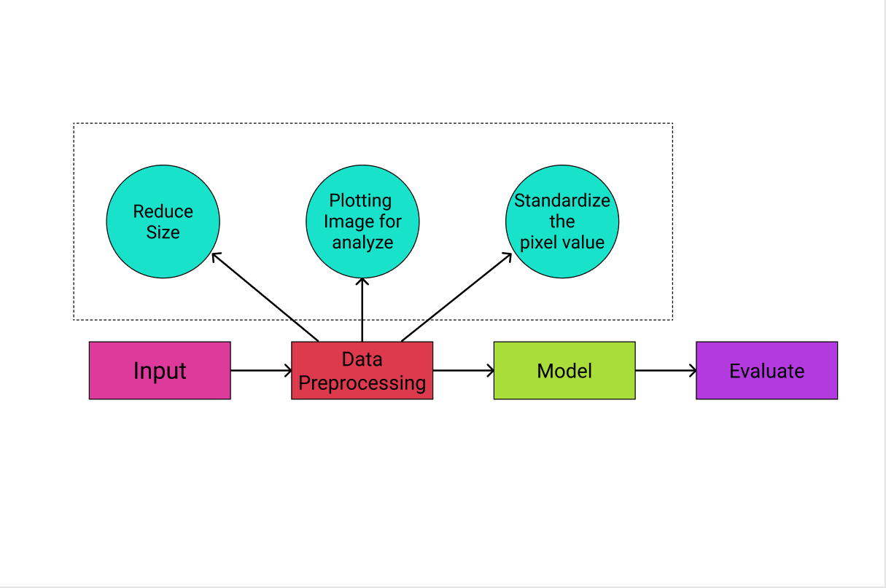

Figure 3 – Showing a look at how a simple model is created

Pre-processing and Feature Extraction of Food-101 Dataset

Before doing anything the first step which we are going to do is pre-process the food-101 dataset by customising and fine tuning the dataset before the dataset is pushed inside the model and get our desired output or say result. This process of pre-processing is also called perimeter optimisation[9]. After choosing the perfect model for your model, the data os the dataset must be standardised according to the need of the model before being shown to the model for teaching. Raw data which we get is not always perfect specially with huge datasets which are mostly unorganised or incomplete, therefore pre-processing of the dataset become an important part of model creation to avoid incompatibility and minimise error[11].

In our case, to start the process of data pre-processing phase, The food images of the dataset and the information of the data images compiled and then labelled manually according to type of data each of them represents. Once this process is completed the next step started which is clustering process. In this process the data is labelled and segmented[11]. For images as input the physical characteristic of images play an important role All these processes are don ein the beginning to facilitate the training of the model later on.

After the process of data pre-processing has been done, the next main step which the process of duplication of sets is done specifically called training, validation, and testing respectively[12]. The purpose of this step is to push a particular data according to the particular need. The training set part is used to input inside the convolutional neural network model to determine the pattern[13]. The validation set is used as the fixed variable and is compared with the trained model. The final part which left called test set is used at the end of the training process to test the final output of the model[14].

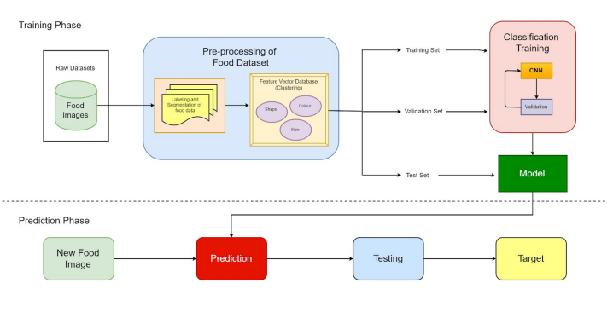

Figure 4 – The proposed framework for deep learning food nutrients composition classification

RESULTS

Now the pre-processing feature extraction we created a trained model through a proper training phase. Now from the training phase, the prediction phase of the deep learning model can be done. Now we are going to use the test data. This is the new data for the model so we are going to put it inside the model so that the model can input data inside it check the patterns transform them and can give us the desired output. In this case, the new data which we need can be any image of food which is shoot from a camera or smartphone lens. Now the model is going to compare the pattern of this images such as colour and shape to the pattern that the model has created during training. The model then may predict the type of food and their nutrient composition of the captured image from the similarities that exist between them.

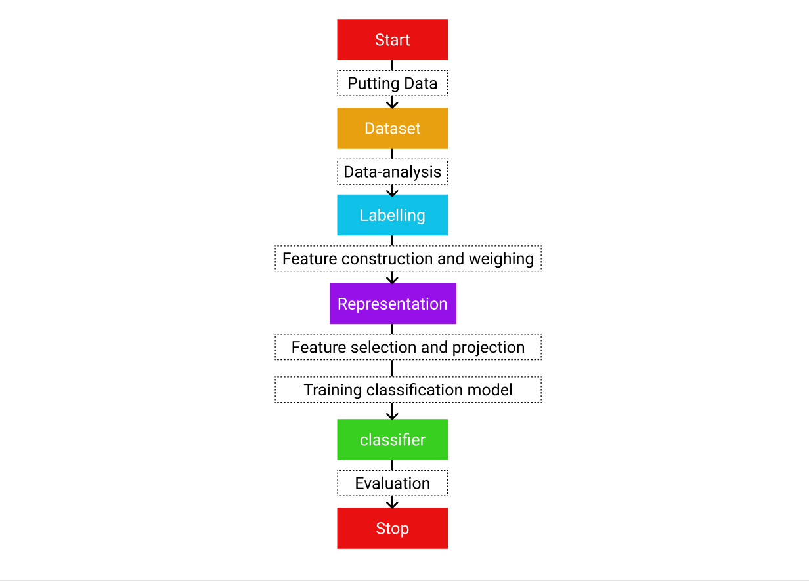

Figure 4 - Showing how a image classification model is created

Table 1 - Table showing accuracy with different models

Graph 1 – Graph showing losses with increasing epoch

CONCLUSION AND FUTURE WORK

With the help of this paper, we try to resolve a major issue of the people who are suffering from some disease because of which they cannot take a proper diet. With the help of this classification model they can have a clear look of what food they are eating and what are nutrients which are present in that food. Including more thing in this we have also explained in detail other food classification published papers using deep learning algorithms that we have used. We created our own deep learning model to implement this classification model. We created multiple model but the main model which we created is with the help of convolutional neural network.

Now let’s talk about the future work, the model created needs to be implemented according to the frameworks which are given and the datasets which are use as stated. In the future we are going to implement convolutional neural network in with some more experiments so that we can get a more desirable output which is important. We haven’t test this model on complete tested because the dataset is too huge, so we are going to make our model more robust so that it can easily distinguish every single food and can give a better result in future.

REFRENCES

[1] David J. Attokaren, Ian G. Fernandes, A. Sriram, Y.V. Srinivasa Murthy, and Shashidhar G. Koolagudi *Food Classiﬁcation from Images UsingConvolutional Neural Networks* on IEEE

[2] Jayne D.Irelanda1AndersMøllerb *Review of International Food Classification and Description*

[3] Abdulkadir Şengür; Yaman Akbulut; Ümit Budak *Food Image Classification with Deep Features*

[4] S. Yang, M. Chen, D. Pomerleau, and R. Sukthankar, “Food recognitionusing statistics of pairwise local features,” in Computer Vision andPattern Recognition (CVPR)

[5] ] L. Bossard, M. Guillaumin, and L. Van Gool, “Food-101–mining discriminative components with random forests,” in European Conference on Computer Vision

[6] Malina Jiang *Food Image Classification with Convolutional Neural Networks*

[7] N. Yao, R. J. Sclabassi, Q. Liu, J. Yang, J. D. Fernstrom, M. H.Fernstrom, and M. Sun,*A video processing approach to the study ofobesity*,

[8] tensorflow site *101-food dataset*

[9] G. Shroff, A. Smailagic, and D. P. Siewiorek, *Wearable context-awarefood recognition for calorie monitoring*

[10] David J. Attokaren; Ian G. Fernandes; A. Sriram; Y. V. Srinivasa Murthy; Shashidhar G. Koolagudi *Food classification from images using convolutional neural networks*

[11] F. Akter, Tania Khatun, Mohammad Shorif Uddin *Recognition and Classification of Fast Food Images*

[12] Diksha Solanki, Ankit Anurag, Dr. Amita Goel, Ms. Vasudha Bahl, Ms. Nidhi Sengar *Detection and Classification of Food Consumption Using Convolutional Neural Networks*

[13] F. Zhu, M. Bosch, I. Woo, S. Kim, C. J. Boushey, D. S. Ebert, andE. J. Delp, *The use of mobile devices in aiding dietary assessment andevaluation*

[14] Pathanjali C, Vimuktha E Salis, Jalaja G, Latha A A *Comparative Study of Indian Food Image Classification Using K-Nearest-Neighbour and Support-Vector-Machines*